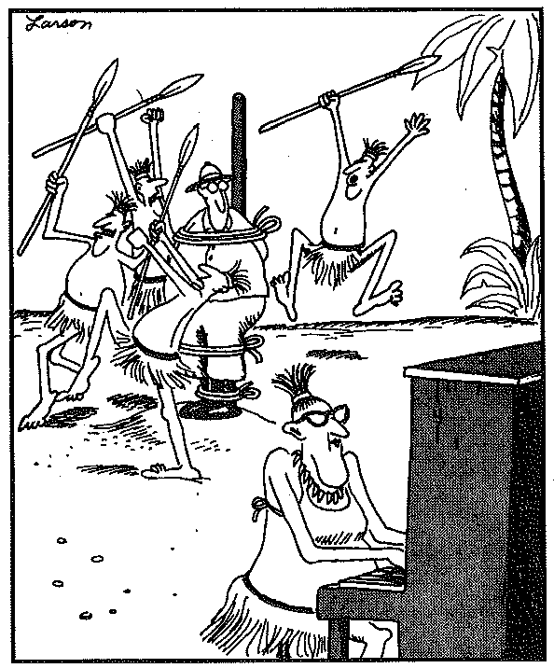
Piano

Handbook

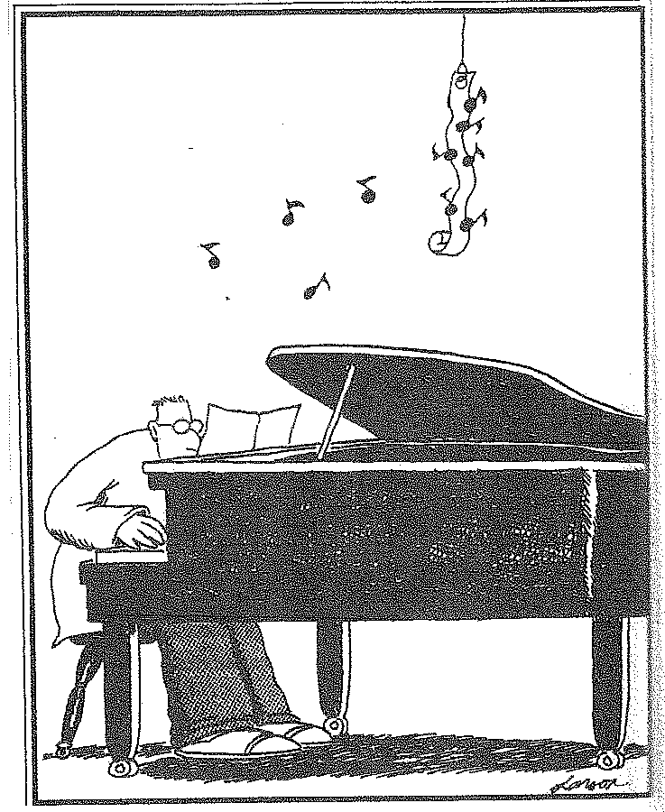

2011 - 2012

Coarse Description
Piano I - 70485
Grades: All, Credit: .5 per semester, Cost: $10 piano book
This class is designed as a beginning piano class. This one semester class includes individual and class instruction. Adequate time is allotted during class for practice. Emphasis is on correct piano technique, basic notation, and development of repertoire. Students should have little or no previous piano background.

Piano II - 70486
Grades: All, Credit: .5 per semester, Prerequisite: Piano I and/or teacher approval
This one semester class is a continuation of the Piano I class. Emphasis will be placed on correct piano technique, simple and complex repertoire, and more advanced music theory. Adequate time is allotted during class for practice.

Supplies
Each student will be provided with an electric keyboard, and a piano book (cost $10). If the student would like to purchase an additional piano book they may do so. Students are also asked to bring a folder to store notes and other assignments, a pencil, headphones with an 8th inch connector, and notebook paper.

Piano Playing Testes
There will be a total of 8 bi-weekly piano playing tests. Each student will be given a log with pages and titles that coordinate with each piano-playing test. Each student must have their log dates and initialed by the instructor and themselves at the time of testing and must turn in the log at the end of the semester.
Grading Rubric
5 points for each category
- Technique: The student plays with correct posture, hand position, and correct fingerings with the corresponding keys.
- Tempo: The student played in a constant tempo with no fluctuation throughout the piece. The performance contained no starts and stops, and no rushing or dragging within the initial selected tempo. If marked in the music, all noted tempo markings are played correctly.
- Pitch Accuracy: All notes in the music were played accurately.
- Rhythmic Accuracy: All rhythms were played accurately and precisely within the selected tempo.
- Musicality: All style markings and dynamics were recognizable during the performance. Selections with no dynamics marked were played with consistent level of volume. Shaping of each phrase was recognizable during the performance.
If a selection was performed well within these benchmarks, a total of 25 points per selection may be earned. 25 X 4 selections = 100 points total

Grading Policies
Semester grades are based on a numerical average of the following:
30% Daily Class Participation
30% Written Assignments
20% Playing Assessments
20% Written Assessments
Quarter and semester grade percentages will be assigned the following letter grades:
90-100% = A
80-89% = B
70-79% = C
60-69% = D
60- % = F

Expectations
Students are expected to abide all rules and regulations stated in the DCSD Code of Conduct and Discipline booklets given during advisement. There are other general rules to follow in Piano Class:
- The Handbook Acknowledgment form needs to be turned in by August 18th (Thursday)
- Food and Drink are prohibited in the Piano Lab
- Cell phones and iPods are prohibited
- RESPECT: Respect yourself, your classmates, and your environment.
- Take care of all class materials and equipment (students will be responsible for any damage to equipment)

_ _ _ _ _ _ _ _ _ _ _ _ _ _ _ _ _ _ _ _ _ _ _ _ _ _ _ _ _ _ _ _ _ _ _ _ _ _ _ _ _ _ _ _ _ _ _ _ _ _ _ _ _ _ _ _ _
Detach and return

Handbook Acknowledgment Form: Beginning Piano 2011 - 2012

I, ________________________________________ (Students Name) have read the handbook and understand the expectations placed upon me as a beginning piano student.

I, ________________________________________ (Parent or Guardian Name) have read the handbook and understand the expectations placed upon my beginning piano student.

Student’s Signature and Date

________________________________________________

Parent/Guardian’s Signature and Date

_________________________________________

