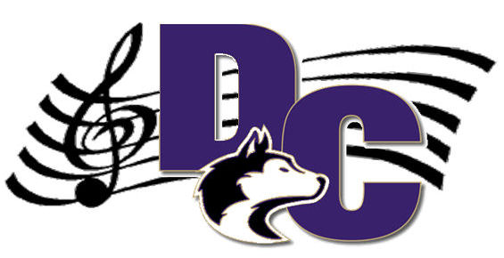

Douglas County High School
Marching Band

Dear Mesa Middle School Band Student,
We are really excited that you are a part of the band program at your school. Band can be an extremely rewarding activity were you can meet lots of people who share the same interests, perform at many places around the country, and create lots of the best memories in school. The Douglas County High School Band Program is excited to know that you will be attending our school in the near future. We would love for you to take the opportunity to be a part of our great marching band program. The DCHS Marching Band performs for the community at football games, at competitions, as well as parades. The band has also won numerous awards, and is regarded as one of the top programs in the state of Colorado.
As we continue these traditions, we are always welcoming new members each year to join in the great experiences of the Douglas County High School Marching Band.

Therefore, as an introduction of what is in store for you as a future Huskie band member, we would like to invite you to perform with the marching band at a football game on September 29th. This would be a great experience and lots of fun. It is also an opportunity for you to meet with the current members of the marching band to get to know more about our program.

Please see our schedule and information on the performance on the back of this page. If you or your parents have any questions, please do not hesitate to contact me. ndbidinger@dcsdk12.org or call 303-387-1093

We hope to see you at our school on September 29th!

Sincerely,

Mr. Bidinger
Band Director
Douglas County High School

