Handbook

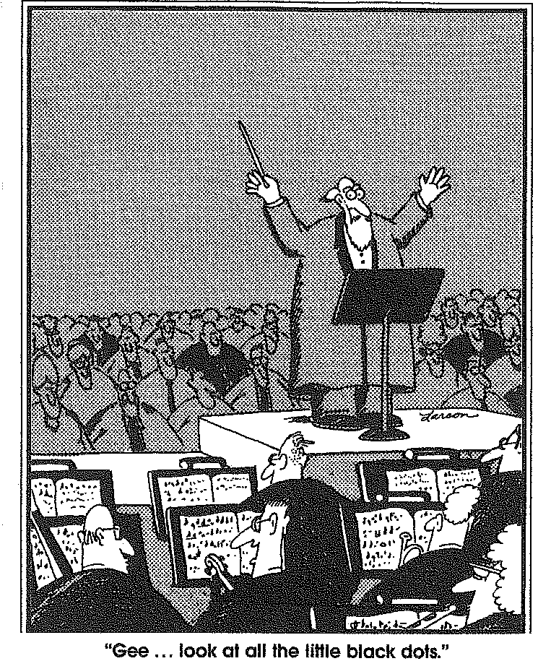
Concert Band,
Symphonic Band,
Wind Ensemble, &
Jazz Band

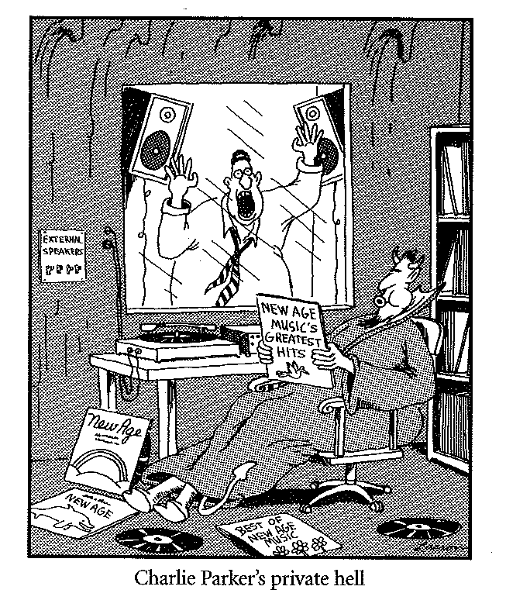

2011 - 2012

Dear Parents and Students,

Welcome to the 2011 – 2012 school year! I am looking forward to a hard working and fun year, as I hope you all are as well. I plan on continuing the great musical and educational experiences here at Douglas County High School. On the following pages you will find the necessary information for this years band classes.

With the new year come some great new opportunities for all of the ensembles. Each ensemble will have an opportunity to participate in a music festival. There will be chances to see outside performing groups such as the Colorado Symphony Orchestra, Colorado Wind Ensemble, several university ensembles, and much more.

I am trying to create new lines of communication so that information can be passed on quickly and efficiently. One way is sending text messages. I will be creating text massage groups for students and parents to receive updates and information. We will also be using Google Groups to send email.

Please read through all of the information in this handbook. On the last pages are a few acknowledgment forms and an information sheet that must be signed by both the student and parent/guardian. The form must be returned within the first two weeks of school. I am very excited to work with all of you this season!

Nick Bidinger
Director of Bands
Douglas County High School
303-387-1093
ndbidinger@dcsdk12.org

Philosophy

I believe that every student should receive a well-rounded and balanced musical education. Each student will be given the tools necessary to achieve a high level of musical competence. Each class’s curriculum will be based around the five Colorado Musical Content Standards. I also believe that with hard work, discipline, and fun comes great reward.

Conduct Policy
Band members are expected to follow all Douglas County School District Code of Conduct, and policies regarding appropriate student behavior stated in the DCSD 2011-2012 Student Rights and Responsibilities Handbook. In the event existing school policy does not identify a particular negative student behavior, the band director will evaluate behavior and appropriate disciplinary action will be determined based upon the severity of the incident and its impact on the band.

Cell Phone/ Electronic Devices Policy
Students may be able to use their cell phones before and after rehearsals and performances. Cell phones are to be turned off, or on “silent mode”, and not in the students’ possession during rehearsals and performances.

Instrument Policies
Each and every student is solely responsible for the care and maintenance of his or her instrument whether it is their own or it is property of the school.

School Owned Instruments
The school owns several instruments available for student use. All damage will be noted on a Student / Parent-Guardian Contract that the student and parent / guardian will be required to sign. By signing the contract the student and parent / guardian agree to repair any damage that occurs beyond normal wear and tear or replace instruments that are deemed beyond repair.

Other Supplies and Care of Instruments:
Wind and Brass Players
It is recommended that each player purchase a metronome, cleaning kit and a tuner. Woodwind players should consider purchasing a reed case to keep their reeds clean and undamaged, and a swab to wipe out the access moisture in the bore of the instrument. Brass players should have their own mouthpieces, valve oil, and slide grease. The students should make sure to permanently place their name on each item for security purposes.

Percussionists
It is recommended that each player purchase a metronome and a stick bag containing at least the following for classroom assignments:
- Vic Firth SD1 Snare Drum Sticks
- Medium yarn mallets
- Hard nylon mallets
- Timpani Mallets Vic Firth T1
The students should make sure to permanently place their name on each item for security purposes.

Instrument Storage
Every student owned instrument should be taken home from school each day for daily practice. The instrument lockers are provided for students to place their instruments during the school day. The instrument room is open only when the director is on property. Students ARE NOT allowed to keep their instruments in any other classroom. All cases must be kept closed at all times, and must be labeled in several ways with the student’s name. A luggage tag is not enough. Students should use the instrument room AT THEIR OWN RISK. Students and parents should be aware that the director is NOT RESPONSIBLE for instruments lost, stolen or damaged. Any incident of students handling instruments that are not belong to them, will be taken very seriously. The administrators, parents and the police will be notified of major offences. This is a serious matter and we currently have a zero tolerance policy.

At the beginning of the school year each student will be issued a shelf or a space and/or locker to place their instrument inside the storage room. They will be responsible to keep that space clean and tidy. In some instances students will have to share that space with another student. Students are expected to respect the property of others and treat it as if it were your own. These lockers and storage spaces are subject to be searched or inspected at any time.

Warm-up Book
Every band student will be using several warm-up books throughout the school year. Students will need to purchase Foundations for Superior Performance. Books can be purchased from the band director at a cost of $7. This book will be used throughout the students entire high school carrier, and is a valuable tool for increasing musicianship.

Sheet Music
Throughout the school year, sheet music will be issued to each student. If a student is absent or loses the sheet music, he or she is responsible for obtaining a new copy. This should be taken care of BEFORE OR AFTER REHEARSAL/CLASS…NOT DURING. Sheet music must be placed in plastic sheet protectors. This will protect the piece of music and also allow for ease of use during performances.

Attendance Policy
The level of commitment from each individual student is the driving force behind the organization and is reflected in the level of achievement reached by the individual and the program. Band is a learning activity. Rehearsals, whether during or after school, or in camp are the means by which students learn, and by their very nature cannot be reproduced or made-up. Therefore it is imperative that students be present unless absence is absolutely unavoidable. Excessive rehearsal absence or non-participation will assuredly affect a student’s performance as well as creating a burden on the ensemble. This is the reason to be absolutely insistent upon each student’s daily participation.
ANY ABSENCE WHETHER EXCUSED OR UNEXCUSED WILL HINDER THE OVERALL SUCCESS OF THE ENTIRE PROGRAM.

Excused Absences - are granted with prior notification in writing, and will be approved on an individual basis. Students that must request permission to miss a rehearsal or performance should use the appropriate forms available from the band director, and submit their request one(1) week prior to the absence. Please note that only excuses for emergency situations will be accepted after an event.

Scheduled Rehearsals & Performances - students are expected to attend all scheduled rehearsals and performances. Students will be excused for illness, death in the family, “once in a lifetime event”, school activity such as the PSAT, College Board, & ACT Testing, academic competitions or school trips.

*School sports conflicts will be resolved with prior mutual agreement of that coach and the band director. We expect you to split conflicting practice times 50% with the band and 50% with the sport. Students will be excused from band practice for games/meets with advance notification. Students are expected to miss sports practice for band performances.

Unexcused absences
WORK - is not acceptable as an excuse. Students that must work should inform their employer of their obligation to the band and with ample advance notice. Most employers are willing to schedule around your band commitments. ANY ABSENCE WITHOUT A WRITTEN NOTE FROM A PARENT WILL BE CONSICDERED UNEXCUSED. This includes other conflicting school functions.

Scheduled Rehearsals & Performance - an unexcused absence from a scheduled rehearsal and or performance will result in a deduction of the student’s grade. Excessive absences may result in the student being removed from future performances. Removal from performances will be at the director’s and administration’s discretion.

Tardy
Tardiness will not be tolerated. Points deducted from the grade and/or other consequences will be at the director’s discretion.

Grading Policies
Instrumental music classes are academic subjects that students receive credit for like any other class. Therefore, grades must be earned as in any other curricular subject. Attendance and participation will be awarded on a daily basis for students showing up to rehearsal on time and prepared, not only with their materials but musically as well. Tardiness will result in loss of half of the daily participation points.
Semester grades are based on a numerical average of the following:
40% Daily Class Participation
20% Playing Assessments
20% Written Assessments
10% Listening Assignments
10% Concert Review

Quarter and semester grade percentages will be assigned the following letter grades:
90-100% = A
80-89% = B
70-79% = C
60-69% = D
60- % = F

Douglas County High School Band
Contact Information

Website (www.dchsband.com)

This is a reliable source of information for upcoming events, performances, award announcements, booster meetings, handbooks, forms, contact information, photos, and much more. The website is usually updated every week during camps and throughout the school year. For each occurrence that it is updated, a date will be will be given to notate that the site contains the latest information. Check it often, especially the “CALENDAR”.

Phone and email
You may contact the DCHS band office at anytime 303-387-1093. The voice mail is active if no one is there to accept your call. If you leave a message including return contact information, you call will be returned promptly. You may also email the director with any questions or concerns at banddirector@dchsband.com.

Other Important Contact Information:

Colorado Institute of Musical Instrument Technology- repair and service
    - www.ciomit.com

Castle Rock Music
    - www.castlerockmusic.com

Flesher-Hinton Music Co.
    - www.flesherhinton.com

Douglas County High School Bands

Student Information
Due by the first day of Band Camp

Student’s Name______________________________Date of Birth: __________
Male______ Female______ Class Grade(circle one): 9 10 11 12
Permanent Address Mailing Address

_________________________________

_________________________________

_________________________________

Home Phone_____________________ Student’s Cell_____________________

Student’s email_____________________________________

Check one: __Wind __Guard __Percussion

Primary instrument________________ Band Courses:____________________

Father’s name___________________________ email____________________

work phone___________________ Cell_____________________

Mother’s name__________________________ email___________________

work phone___________________ Cell_____________________

Emergency contact: ______________________Phone: __________________

Relation to student: _____________________________________

What sports or activities are you planning to participate in this year?

Douglas County High School Bands

Due by the first day of Band Camp
Authorization to Treat a Minor
I (we) the undersigned parent(s) or legal guardian(s) of the undersigned student do hereby authorize and consent to any x-ray examination, anesthetic, medical or surgical diagnosis rendered under the general or specific supervision of any member of the medical staff and emergency staff licensed under the provisions of the Medical Practice Act or a dentist licensed under the provisions of the Dental Practice Act and on the staff of any acute general hospital holding a current license to operate a hospital from the Colorado Department of Public Health. It is understood that this authorization is given in advance of any specific diagnosis, treatment or hospitalization being required but is given to provide authority and power to render care which the aforementioned physician, in the exercise of his or her best judgment, may deem advisable. It is understood that the effort shall be made to contact the undersigned prior to rendering treatment to the patient, but that any of the above treatment will not be withheld if the undersigned cannot be reached.

Student Name____________________________________________________

May we administer Tylenol/Advil if requested by the student? YES____ NO____

List ANY special health problems in the past: ___________________________

List ANY medications taken currently and reasons: (include insulin, anti-convulsive, antihistamine, and tranquilizers) _____________________________________________________________________________

Family Physician: _______________________ phone:____________________

Date of last Tetanus injection: ________________________

List all allergies to drugs or food: ________________________________________________________________

Insurance Company________________________________________________

Group Number_______________________

Policy Number________________________

Parent/Guardian Signature Date

 Training Rules and Expectations /Parent or Guardian Advisement and Permit

High-School Athletics and Activities
Training Rules & Expectations

As a representative of DCSD’s activity and athletic programs, I understand and accept that:
- It is my privilege and honor to wear my school colors
- I am a leader in and out of uniform
- My actions are a reflection of myself, my family, my school, and community
- I’m accountable for my performance in the classroom and my conduct in the community.
In exchange for the opportunity to participate in DCSD interscholastic activities or athletics (abbreviated here as “Activities”), and in accordance with Policy JJI, I agree to the following:

Scope of Rules
From the day a student first participates in a DCSD high-school Activity until that student graduates from high school, these rules remain in effect, throughout the school year, during summer, fall, winter and spring breaks, including weekends, vacations, and holidays, and regardless if the student is on or off DCSD property.

The consequences outlined here are in addition to, not instead of, those the student may receive under the DCSD’s Code of Conduct, the Colorado High School Activities Association By-laws, coaches’ team rules, or other sources. They represent minimum sanctions; the Principal or designee may increase or modify these consequences in particular cases or in general as he or she deems appropriate.

Although some prohibited behaviors listed below refer to DCSD’s Code of Conduct, because these training rules are in effect at times and in places when the Code of Conduct may not be, and because students who participate in Activities are held to higher behavioral expectations than other students, the Principal or designee may determine that a student’s conduct constitutes grounds for imposing an Activity penalty under these rules even when that conduct does not result in suspension or expulsion under the Code of Conduct.

Prohibited Behaviors
- Violating DCSD’s policies regarding drugs & alcohol (JICH) and tobacco use (JICG)
- Violating DCSD’s weapons policy (JICI)
- Violating DCSD’s gang-related behaviors and dress policy (JICF)
- Violating any criminal law
- Continued willful disobedience or open and persistent defiance of proper authority
- Willful destruction or defacing of school property
- Behavior detrimental to the student’s, other students’, or school personnel’s welfare, health, or safety
- Any other conduct that would constitute grounds for suspension under DCSD policy JKD/JKE.

Consequences
The following minimum consequences will result whenever the Principal or designee concludes that a student has engaged in any of the prohibited behaviors listed above.

- First offense: For Activities with 11 or fewer regular-season contests, the student will be suspended for the next contest; for those with more than 11 regular-season contests, the student will be suspended for the next 2 contests. These suspensions will be imposed whether or not the next contest or contests are regular-season contests or are special events, tournaments, or qualifiers.

- Second offense: The student will be suspended from all Activities throughout DCSD for 1 full year from the date of the infraction.

- If, however, a student initiates contact with school authorities to voluntarily report his or her involvement in conduct prohibited by these rules, then the student will be eligible for the following lesser second offense penalty: The student will be suspended from the remainder of the season of the Activity he or she was participating in at the time of the conduct and, upon proof that the student has successfully completed an intervention class chosen by the school athletic director, the student will only be suspended from the first 50% of the regularly scheduled contests of the next Activity that the student participates in for an entire season.

- Third offense: The student will be suspended from all Activities throughout DCSD for 1 full year from the date of the infraction, except that if a second offense suspension is still in effect, then the date of the third offense suspension will not begin on the date of the infraction, but rather will begin on the day after the second offense suspension ends.

Tobacco Consequence Only:
- First offense: The student receives a warning and must attend site based tobacco education or community service.

- Second offense: For Activities with 11 or fewer regular-season contests, the student will be suspended for the next contest; for those with more than 11 regular-season contests, the student will be suspended for the next 2 contests. These suspensions will be imposed whether or not the next contest or contests are regular-season contests or are special events, tournaments, or qualifiers.

- Third offense: The student will be suspended from all Activities throughout DCSD for 1 full year from the date of the infraction, except that if a second offense suspension is still in effect, then the date of the third offense suspension will not begin on the date of the infraction, but rather will begin on the day after the second offense suspension ends.

Nothing in these rules prohibits the Principal, designee, or individual coaches from establishing and enforcing additional rules applicable to Activities, such as lesser or different penalties for failing to exercise good sportsmanship at practices or competitions or for failing to demonstrate good citizenship at school or school-sponsored events.

I have read and agree to follow these rules:

Student’s Name (print) Signature Date

Parent or Guardian’s Name (print) Signature Date

STUDENT AND PARENT OR GUARDIAN ADVISEMENT AND PERMIT
Colorado High School Activities Association Rules and Regulations state that no pupil shall participate in interscholastic activities until he/she is on file with the appropriate office: (a) a statement signed by his or her parent or legal guardian that he/she has the consent to participate and (b) a statement from a practicing physician certifying that the pupil is physically fit to participate in high school interscholastic activities.
Concussion Evaluation Information
If your child is involved in a contact sport*, he/she may be administered a computerized neurocognitive assessment called ImPACT, to determine how he/she performs in a healthy state. In case of a head injury, DCSD personnel will use this same assessment to assist in determining an athlete's ability to return to play. ImPACT is only one part of a comprehensive process to help your student recover after suffering a head injury. Information may be shared with relevant professionals to support the injured athlete. The Certified Athletic Trainer, School Psychologist and the School Nurse Consultant work together to follow the student to recovery.
*The sports that are considered contact sports include but are not limited to football, basketball, baseball, wrestling, cheerleading, lacrosse, soccer and softball.
Medical Clearance and/or Release for Activity
Per Douglas County School District Athletic Training Handbook 4th Edition — August 2011 …
“A healthcare provider may release the student athlete from his/her care, but the athletic trainer, as a medical professional representing Douglas County School District, will make the final decision on return to play status.
WARNING: Although participation in supervised interscholastic athletics and activities may be one of the least hazardous in which any student will engage in or out of school, BY ITS NATURE, PARTICIPATION IN INTERSCHOLASTIC ATHLETICS INCLUDES A RISK OF INJURY WHICH MAY RANGE IN SEVERITY FROM MINOR TO LONG-TERM CATASTROPHIC. Although serious injuries are not common in supervised school athletic programs, it is impossible to eliminate the risk. Participants can and have the responsibility to help reduce the chance of injury. PLAYERS UNDERSTAND AND, BY THEIR PARTICIPATION, AGREE THAT THEY MUST AND WILL OBEY ALL SAFETY AND TRAINING RULES, FOLLOW DIRECTIVES OF THE COACHES, PROMPTLY REPORT ALL PHYSICAL PROBLEMS TO THEIR COACHES, FOLLOW A PROPER CONDITIONING PROGRAM AND INSPECT THEIR OWN EQUIPMENT DAILY. By signing this Permission Form parents and student acknowledge that they have read and understand this warning. PARENTS OR STUDENTS WHO DO NOT WISH TO ACCEPT THE RISKS DESCRIBED IN THIS WARNING SHOULD NOT SIGN THIS PERMISSION FORM.

We understand that coaches, trainers and team physician may use their own judgment in securing medical aid and ambulance service in case of an emergency or in mild injuries where parents cannot be reached. Also the team physician, trainer and/or coach may apply first aid treatment until the family physician can be contacted.

I have read the forgoing, acknowledge the “WARNING” above, accept the risks described and agree to abide by the principles and regulations contained therein.

X ___________________________________________________________ ___________________________
Signature of Student Date

I/We have read the foregoing, acknowledge the “WARNING” above, accept the risks described and hereby give consent for the above named student to participate in interscholastic athletics within the Douglas County School District Re. 1, in the following Colorado High School Activities Association approved sports except those crossed out: Baseball, basketball, cross country, field hockey, football, golf, gymnastics, lacrosse, soccer, softball, swimming, tennis, track and field, volleyball and wrestling. Consent includes spirit teams, managing and training unless crossed out.

X ___________________________________________________________ ___________________________
Signature of Parent or Guardian Date

INTERSCHOLASTIC ACTIVITIES INSURANCE WAIVER
I fully understand the Douglas County School District Re. 1 does not provide health or life insurance coverage for the above named student while he/she is participating in the activities associated with interscholastic sports. I/We further understand that it is my/our responsibility to provide adequate insurance coverage to the above named student.

X ___________________________________________________________ ___________________________
Signature of Parent or Guardian Date

Transportation Awareness
Consent and Release

STUDENT NAME _______________________________ GRADE __________________

The Douglas County School District (the “District”) provides District transportation for students to and from a great many activities, events, matches and games. However, the District is unable to provide District transportation in all circumstances and to all events. When District transportation is not available, it is the student’s parent’s/guardian’s responsibility to provide or arrange for their student’s transportation to and from the event.

When District transportation is not available and other alternative forms of transportation are utilized, the District cannot and does not assume any responsibility for the safety, training of drivers, condition of vehicles, adequacy for the use or purpose intended or any other matters related to any non-District transportation.

Therefore, we, the undersigned parent/guardian and student, hereby acknowledge, agree and understand that the District does not insure, endorse, approve or sponsor any form of non-District transportation, whether by parents, students or otherwise, to and from District off-campus activities or events. We further acknowledge it is our responsibility to provide or arrange for our/my child’s transportation to District events when District transportation is not available. As such we consent to our child’s use of alternative means of transportation, including private vehicles driven by parents, and, if applicable, consent to our child’s use of a vehicle to transport himself/herself to off-campus events. We hereby waive, release, discharge and agree to hold harmless and indemnify the District, its agents, employees, insurers and Board of Education, from any claim, cause of action, damage, injury, or demand of any nature, including bodily injury, property damage or death, arising from or sustained during or as a result of my/our child’s utilization of or participation in any non-District transportation, whether furnished by us, our student, parent or otherwise.

Parent/Guardian Signature Date

Student Signature Date

Band Member Contract 2011-2012

Before a student can participate in rehearsals they must have a completed band member contract on file. Students that do not return a signed contract will be dropped from the band roster.

My parent(s) and I have read all of the information provided in this handbook. It is known that any and all applicable policies are subject to change at anytime by the band director, and we will note any amendment to this handbook. We are committed to any event that the band must participate, and will adhere to the provided calendar. It is also known that events may be added to or deleted from the calendar with advance notice.

I intend to give my greatest efforts to achieve the best musical experiences as a member of the Douglas County High School Marching Band.

___________________
date

___________________________________
Student’s signature

____________________________________
Student’s name (print)

___________________________________
Parent’s signature

____________________
Parent’s name (print)

